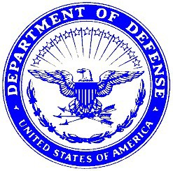
DEPARTMENT OF THE AIR FORCE
UNITED STATES AIR FORCES CENTRAL COMMAND (USAFCENT) 379TH AIR EXPEDITIONARY WING

DD/MMM/YY
MEMORANDUM FOR 379 EFSS/FSVF
FROM: (Squadron CC or Equiv)
SUBJECT: Exception to Policy for Ground Support Meals

1. Who requires Ground support meals? When does X unit require ground support meals (Describe/break down the meal periods in which meals will be required, as well as the number of meals needed?)

2. Why does X unit require ground support meals? (Provide Justification on why and ETP for Ground Support meals is needed) Where does X unit like to pick-up Ground Support Meals (Cold grab or Pearl Dining Facility). How is ground support meals going to be picked up?

3. If you have any questions concerning this memorandum, please contact POC at DSN 455-xxxx.

CC SIGNATURE BLOCK,
Commander,

1st Ind, 379 EFSS/CC
MEMORANDUM FOR (Squadron CC or Equiv) Approved/Disapproved

ROBERT M. BRUCE, Lt Col, USAF
Commander, 379 EFSS

Generate Combat Airpower

